Міністерство освіти І науки УКРАЇНИ

Придніпровська державна академія
Будівництва та архітектури

КАФЕДРА ІНОЗЕМНИХ МОВ

МЕТОДИЧНІ ВКАЗІВКИ
до практичних занять з дисципліни
«Іноземна мова за професійним спрямуванням»
на тему «SUSTAINABILITY FOCUS»
для здобувачів першого (бакалаврського) рівня
вищої освіти спеціальності 192 «Будівництво та цивільна інженерія» денної форми навчання.

Дніпро

2022
Методичні вказівки на тему «Sustainability focus» до практичних занять з дисципліни «Іноземна мова за професійним спрямуванням» для здобувачів першого (бакалаврського) рівня вищої освіти спеціальності 192 «Будівництво та цивільна інженерія» денної форми навчання. /Укладачі: Соколова К.В., Щетинникова О.О. – Дніпро: ПДАБА, 2022. – 28 с.

Методичні вказівки на тему «Sustainability focus» розроблені на основі аутентичного текстового матеріалу та орієнтовані на засвоєння тематичної лексики, розвиток та формування рецептивних та продуктивних навичок мовного професійного спілкування у межах теми «Сталий розвиток».

Укладачі: Соколова К.В. зав. кафедри іноземних мов ПДАБА;
Щетинникова О.О., ст. викладач кафедри іноземних мов ПДАБА

Відповідальний за випуск: Соколова К.В., к.філос.н., доцент, завідувач кафедри іноземних мов ПДАБА

Рецензент: Шашкіна Н.І., к.філол. н., доцент кафедри іноземних мов ПДАБА

Затверджено на засіданні
кафедри іноземних мов ПДАБА
Протокол № 10 від 20.12.2021

Рекомендовано до друку
навчально-методичноою радою ПДАБА
Протокол № 4 від 17.02.2022

CONTENTS

Unit 1 What is sustainability? ……………………………………… 4
Unit 2 Sustainability in construction ………………………………... 6
Unit 3 Renewable resources …………………..................................... 11
Unit 4 Carbon footprint and energy efficiency ………………….... 15
Unit 5 Energy efficiency ……………………………………………… 17
Unit 6 Zero net homes ………………………………………………… 20
Unit 7 Supplementary Reading ………………………………………. 23
References ………………………………………………………………. 29

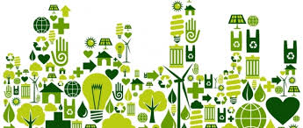

UNIT 1
WHAT IS SUSTAINABILITY?

sustainability /səsteɪnəˈbɪlɪti/ noun

- the ability to be maintained at a certain rate or level: "the sustainability of economic growth"
- avoidance of the depletion of natural resources in order to maintain an ecological balance: "the pursuit of global environmental sustainability"
http: dictionary.cambridge. org


 Watch the video using QR code or link

https://youtu.be/rmQby7adocM

Task 1 Watch the video (0:00-2:33) and give the right answer to the following multiple-choice questions:

1. What is the basic idea of sustainability?
- It is only about protecting the climate.
- It is the idea that a product or an idea has the ability to continue in the future.
- It is only about protecting the oceans.

2. Another part to sustainability is
- the ability of something to maintain or continue itself.
- the ability of something to break down.
- the ability to keep something clean.

3. As a world-society, we need to
- use resources immediately.
- preserve, or protect, resources and energy for long-term goals.
- rebuild cities.

4. Today sustainability means to
- preserve (protect) natural resources
- conserve (protect) materials
- maintain (continue) resources
- all of the above.

Task 2. Watch the video (0:00-2:33) and tick all the true sentence:

1. We often associate sustainability with things like recycling, using renewable energy sources.

2. Sustainability is the capacity to endure or continue

3. Sustainability deals with short-long needs or goals.

4. The term sustainability first appeared in economic studies.

5. Hartig’s definition of sustainability has the same meaning as our current definitions.

Task 3. While watching the video (2:34-5:26). read the transcript and fill the gaps.

Sustainability seeks new ways of addressing the relationship between societal _________ and environmental ___________, which would allow human societies and economies to grow without destroying or overexploiting the environment or ecosystems in which those societies exist. The most widely quoted definition of sustainability comes from the Brundtland Commission of the United Nations in 1987, which defined sustainability as meeting “the needs of the present without compromising the ability of future generations to meet their own needs”.
But sustainability is about more than just the economic benefits of __________________ and ___________. While the economic factors are important, sustainability also accounts for the social and environmental consequences of human activity. This concept is referred to as the “three pillars of sustainability,” which asserts that true sustainability depends upon three interlocking factors:___________________ , social equity, and economic viability.
First, sustainable human activities must protect the earth’s environment. Second, people and communities must be treated fairly and equally—particularly in regard to eradicating global __________ and the environmental exploitation of poor countries and communities. And third, sustainability must be economically ____________—human development depends upon the long-term production, use, and management of resources as part of a global economy. Only when all three of these pillars are incorporated can an activity or enterprise be described as sustainable. Some describe this three-part model as: Planet, People and ___________.

Task 4. Work in pairs and compare your answers. Say how you understand sustainability and its importance.

Example:

A. Do you think we need to know about sustainability more?

B. I think, yes

A. Why?

B. Because we must think about our future.

Unit 2

SUSTAINABILITY IN CONSTRUCTION

Over to you:

How do you understand sustainability in construction?

What is ‘green construction’?

Task 1. Match the words with their definitions:

1. | to expand | a | the act of using, eating, or drinking something
2. | renewable | b | to get better, or to make something better
3. | recyclable | c | having many different types of animals and plants
4. | consumption | d | to increase something in size, number, or importance
5. | emissions | e | materials or products that can be used again after they have been treated using a special industrial process
6. | to improve | f | to become or to make something become smaller in size, amount, degree, importance, etc
7. | to reduce | g | amounts of gas, heat, light, etc. that is sent out
8. | biodiverse | h | relating to forms of energy that are produced using the sun, wind, etc., or from crops, rather than those using fuels such

Task 2. Read the text

What Is Sustainable Construction And Why Is It Important?

The construction industry must help to build a world that will improve the lives of future generations and use eco-friendly methods. Working sustainably involves meeting demands of the expanding population, as well as supporting the environment in the long-term.
Sustainable construction means building with renewable and recyclable resources and materials. During construction projects, care must be taken to reduce waste and energy consumption where possible and protect the natural environment around the site. The end result of a sustainable construction project must be an environmentally friendly building or environment.
According to the Supply Chain Sustainability School, building and construction works in countries which are part of the Organisation for Economic Co-operation and Development (OECD) use:
- 25-40% of total energy
- 30% of raw materials
- 30-40% of global greenhouse gas emissions
- 30-40% of solid waste generation.
This is why sustainable construction is developing as a solution.
Sustainable construction poses numerous benefits which can be separated into the following three categories:
Environmental: using renewable energy and building materials will help in the fight against climate change. Plus, greener buildings will improve waste management and emissions. According to The World Green Building Council: “Green buildings can not only reduce or eliminate negative impacts on the environment, by using less water, energy or natural resources, but they can - in many cases - have a positive impact on the environment (at the building or city scales) by generating their own energy or increasing biodiversity”.

Financial: sustainable construction is sometimes criticized for using expensive materials, but green buildings are often considered more valuable than traditional ones. Data has shown they achieve a 7% increase in their value over traditional buildings, plus savings on utility bills for tenants or households are also more likely through sustainable construction projects.
Social: not only does sustainable construction mean improved health for the people who use the buildings, it also has been shown to improve workers productivity during construction thanks to better surroundings, work environments, and noise protection.

Task 3. Answer the following questions:

1. What is sustainable construction?

2. Why is sustainable construction important?
3. What are the benefits of sustainable construction?

Task 4. Match the words to make collocations from the text:
1. | sustainability | a | population
2. | noise | b | generation
3. | renewable | c | construction
4. | expand | d | energy
5. | energy | e | friendly
6. | waste | f | protection
7. | environmentally | g | consumption

What is sustainable Construction?

Watch the video using QR code or link

https://www.youtube.com/watch?v=EgdnqeIMSuI

Task 1. Answer the questions:

- What kind of balance is there in the sustainable construction?
- What impact has got a construction industry on the environment?
- Does sustainability in construction mean the same as energy efficiency?
- Why is sustainability important?

WHY THE BUILDING SECTOR?

Task 1. Read the abstracts and think about the possible solutions to change the situations.

Buildings generate nearly 40% of annual global CO2 emissions. Of those total emissions, building operations are responsible for 28% annually, while building materials and construction (typically referred to as embodied carbon) are responsible for an additional 11% annually.

EXISTING BUILDINGS. Approximately 2/3 of the global building area that exists today will still exist in 2040.

Without widespread existing building decarbonization across the globe, these buildings will still be emitting CO2 emissions in 2040 and we will not achieve the Paris Agreement’s 1.5°C target.

Achieving zero emissions from the existing building stock will require leveraging building intervention points to accelerate the rate of energy upgrades (increasing energy efficiency, eliminating on-site fossil fuels, and generating and/or procuring 100% renewable energy).

NEW CONSTRUCTION. Global building floor area is expected to double by 2060. To accommodate the largest wave of urban growth in human history, we expect to add 2.4 trillion ft2 (230 billion m2) of new floor area to the global building stock, the equivalent of adding an entire New York City to the world, every month, for 40 years.

Achieving zero emissions from new construction will require energy efficient buildings that use no on-site fossil fuels and are 100% powered by on- and/or off-site renewable energy.

EMBODIED CARBON. Just three materials – concrete, steel, and aluminum – are responsible for 23% of total global emissions (most of this used in the built environment).

There is incredible opportunity for embodied carbon reduction in these high-impact materials through policy, design, material selection, and specification.


Task 2. Visit website https://architecture2030.org/why-the-building-sector/ section Actions for….and compare your ideas with the given propositions

Materials Used In Sustainable Construction

Task 1. Name the materials which can be used in sustainable construction.

Task 2. Find a correct description of the material given below:

wood plastic concrete brick staw
1.__________ the dried, yellow stems of crops such as wheat, used as food for animals or as a layer on the ground for animals to lie on, and for making traditional objects.
2._________ a very hard building material made by mixing together
cement, sand, small stones, and water.
3. _________ a hard substance that forms the branches and trunks of
trees and can be used as a building material, for making things, or as a fuel.
4. __________ an artificial substance that can be shaped when soft into many different forms and has many different uses.
5. __________ a rectangular block of hard material used for building walls
and houses.

Task 3. Read the text.

There are endless ways in which construction companies can improve sustainability and reduce their carbon footprint, such as:
- Using renewable energy
- Using on-site water treatment plants to minimise waste
- Recycling and building with renewable or waste materials, e.g; cigarette butt bricks.
Other materials used in sustainable construction are:

Wood. Wood is a great material as it doesn’t require a lot of energy to become a building material. Properly managed forests not only supply renewable material, but also provide a biodiverse habitat for wildlife preservation

Recycled plastic. Plastic is fast becoming a sustainable construction material which is relatively easy to obtain thanks to an abundance of it existing in most societies. In some places, plastic and other rubbish are turned into concrete replacements, reducing greenhouse gasses and helping to stop landfills becoming overrun with materials.

Sustainable concrete. Concrete is a widely used synthetic material, but also one of the most environmentally unfriendly. Its manufacture alone is responsible for about 5% of global carbon dioxide (CO2) emissions. Fortunately, many companies are now exploring ways to reduce emissions by creating alternatives with plastic and other recyclables, which can reduce the carbon dioxide production by almost 50%.

Mud bricks & wool bricks. Bricks use kiln-fires to increase their strength resulting in pollution through greenhouse gases, but in 2010 researchers from the Schools of Architecture at the University of Seville, Spain and the University of Strathclyde in Glasgow, UK found new and greener ways to produce bricks just as strong, with untreated clay or wool as part of their composition.

Straw. Straw bales can be used in place of concrete or plaster for insulation. Straw is not only sustainable, but affordable too, which helps keep the costs of building materials down.

Tasks 4. Are the given sentences below True or False?

1 | Wood requires a lot of energy to become a building material. | Т | F
2 | Plastic is a widespread material and can be easily recycled. | Т | F
3 | Concrete could be environmentally friendly unless it produces about 5% of global carbon dioxide (CO2) emissions | Т | F
4 | Clay or wool as part of bricks composition can make them stronger | Т | F
5 | Straw is not sustainable, but affordable material which helps keep the costs of building materials down | Т | F

Task 5. Give synonyms to the words in bold in the text.
Unit 3
RENEWABLE RESOURCES

Over to you:
What examples of renewable energy can you give?
What types of energy are mainly used in your country?
What kind of industries can renewable energy be applied in?

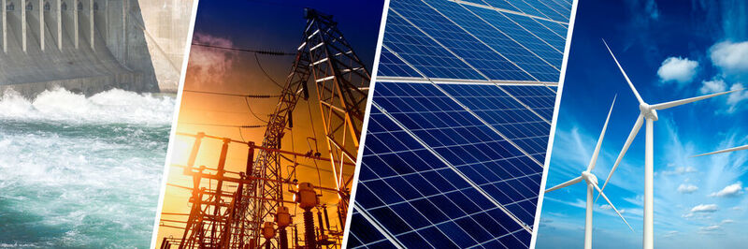

Task 1. Use a dictionary to find equivalents in your native language for the following word combinations:

solar energy | energy costs | fossil fuels | generate electricity
wind turbines | geothermal energy | turbine blades | fastest-growing
emit pollution | long-term storage | viable sources | significant potential

Task 2. Read the text and match abstracts with the headlines:

- They create jobs  - Reliability issues  - Hydroelectric renewable energy  - Geothermal renewable energy  - They save money | - Solar renewable energy  - Renewable energy challenges  - Takes up space  - Not totally green  - They won’t run out  - Wind renewable energy

A renewable resource is one that can be used repeatedly and does not run out because it is naturally replaced. Examples of renewable resources include solar, wind, hydro, geothermal, and biomass energy. Renewable energy, sometimes referred to as “clean” or “green” energy, is a booming innovation that is bringing down energy costs and delivering on its promise of a cleaner, greener future. This means that renewable energy sources are slowly but surely displacing “dirty” energy sources, such as fossil fuels (e.g., coal and oil) in the power sector and offering the benefit of lower emissions and pollution levels.

1____________________
Solar energy is energy that comes from the sun. This is harnessed by solar (or photovoltaic (PV)) cells made from silicon that is found in solar panels. These cells transform sunlight into electricity. The most common types of solar systems are those found on top of rooftops that generate electricity locally for homes and businesses. However, solar panel systems on a large enough scale can be powerful enough to power entire neighborhoods and provide electricity for thousands of homes. Solar is now seen as such a viable energy source, in fact, that most developed nations have government-backed schemes and incentives that “reward” home and business owners for installing solar panels on their property. These include everything from cashback and tax breaks to paying homeowners to “sell” their surplus power to national power grids. Solar is an example of zero-carbon energy; it doesn’t produce any pollutants or harmful by-products beyond those generated during the solar PV cell manufacturing process.
2_______________________
Today, wind energy is harnessed through wind turbines that in some cases can be as tall as skyscrapers. While wind turbines are usually found on-shore, but they can also be found off-shore where wind speeds tend to be higher. A turbine system works by the wind energy turning its blades. This feeds an electric generator and produces electricity which can then be used by the grid. The wind has quickly become the cheapest energy source available in many parts of the world.

3_________________
Hydroelectric renewable energy is one the largest renewable energy source, in the United States in particular, but wind energy is expected to catch up soon. While it is a viable renewable energy source, there is limited potential for it to be captured because it relies on fast-flowing water, such as that found in a river or waterfall, descending from a high point to create a force that spins a generator’s turbine blades. That being said, there are many who argue that hydroelectric is not in fact a renewable source. This is because large-scale hydroelectric plants can sometimes reduce natural water flows and restrict access to animal habitats and human populations that rely on rivers and waterways for survival. On a smaller scale, however, carefully managed hydroelectric plants are not thought to be damaging to the environment.

4_________________
Geothermal energy is the heat that comes from the sub-surface of the Earth. It is contained in the rocks and fluids beneath the earth’s crust and can be found as far down to the earth’s hot molten rock, magma. To create power from geothermal energy, wells must be dug deep into underground reservoirs to access the steam and hot water they contain. This can then be used to drive turbines connected to electricity generators.
Geothermal energy is used in over 20 countries. The most famous countries with geothermal activity are the United States (California’s geysers) and Iceland, which has been used as far back as 1907 to produce over 25 percent of its energy.
Renewable energy sources have the potential to be transformative for our world. Here are some of the key advantages that they have over fossil fuels and other dirty energy sources:
5__________________
Renewable energy technologies make use of resources that come straight from the environment to generate electricity. These energy sources include sunshine, wind, water, and heat to name a few. The biggest advantage of these resources is that they simply won’t run out, which cannot be said for many types of fossil fuels - while fossil fuels do regenerate, it takes millions of years for this to happen.
6________________
Using renewable energy can help us to save money in the long run. Not only do renewable energy technologies come with lower maintenance requirements, but their operating costs are lower also. When we are using technologies that generate power from natural sources such as the sun, for example, there is no need to pay to refuel as we do with fossil fuels. While entry costs have historically been high for things like solar panels and electric vehicle chargers, government incentives and improvements in technology are making them much cheaper and, in some cases, non-existent.
7________________
The renewable energy sector is booming, and this is creating more and more jobs - from research scientists to turbine technicians.
The renewables sector is also one of the fastest-growing worldwide, and thus is creating more employment opportunities with each passing day. There is significant potential across the entire spectrum, from research and development to construction and maintenance.

8____________________
While solar, wind, hydroelectric, and geothermal renewable energies are popular and viable sources of energy and could be the key to fighting off climate change, there are some challenges that are important to consider.
9_____________________
Renewable energy technologies depend entirely on weather conditions. If it’s not windy, wind turbines can’t turn. If it’s not sunny, less solar energy can be captured. If atmospheric conditions are not optimal enough, renewable energy technologies might not generate any electricity at all. For example, wind turbines require a minimum wind speed to move their blades while hydro generators require enough water flow to spin their turbines.
This is especially problematic when we consider the fact that when renewable technologies are working, they tend to produce a surplus of energy (i.e., more than is being used) which cannot be stored anywhere due to the lack of long-term storage options.
10_________________
Setting up renewable energy generation facilities, even on a smaller scale in the home, requires not only a potentially huge capital investment but also a lot of free space for installation. While this is OK in the case of solar panels on the roofs of private homes, it becomes much more problematic on a larger scale where 40 hectares of green space might be used up to accommodate solar panels that might only generate about 20 megawatts of energy. Meanwhile, a nuclear power plant can theoretically generate roughly 180 megawatts of energy in the same amount of space.
11______________
While renewable sources are clearly the better option than fossil fuels, it still generates pollution. Many renewable energy technologies are created via manufacturing processes that emit a huge amount of pollution, and many of the resources needed for renewables are built using fossil fuels. There are also some examples of renewable energies that directly create pollution, the biggest one being biomass energy that requires the burning of organic matter which releases pollutants into the atmosphere.

Tasks 2. Answer the following questions:

1. What is solar renewable energy?

2. What is wind renewable energy?

3. What is hydroelectric renewable energy?

4. What is geothermal renewable energy?

5. What are the key advantages of renewable energy sources?

Unit 4

CARBON FOOTPRINT AND ENERGY EFFICIENCY
Over to you:
How do you understand “a carbon footprint”?
What are the ways to save energy?

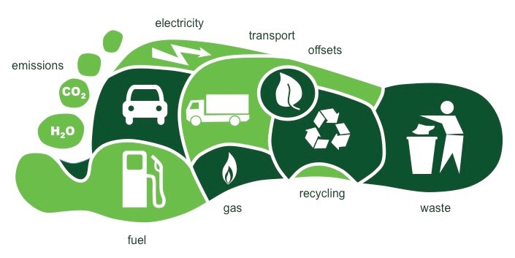

Task 1. Read the definitions and choose the one which you like most.

There are some definitions of “carbon footprint”:

1. A carbon footprint is the total set of greenhouse gas emissions caused directly and indirectly by an [individual, event, organisation, product] expressed as CO2e.
by the Carbon Trust
2. A carbon footprint is the amount of carbon dioxide (CO2) emissions associated with all the activities of a person or other entity (e.g., building, corporation, country, etc.). It includes direct emissions, such as those that result from fossil-fuel combustion in manufacturing, heating, and transportation, as well as emissions required to produce the electricity associated with goods and services consumed.
www.britannica.com
3. A carbon footprint is a measure of the impact your activities have on the amount of carbon dioxide (CO2) produced through the burning of fossil fuels and is expressed as a weight of CO2 emissions produced in tonnes.
by World Health Organization

HOW BIG IS YOUR FOOTPRINT?

Carbon footprints are different from a country’s reported per capita emissions. Rather than the greenhouse gas emissions associated with production, carbon footprints focus on the greenhouse gas emissions associated with consumption. When discussing emissions on a national or global scale, carbon footprint is typically expressed in units of CO2—typically metric tons (1,000 kg/2,205 lb = 1 t), million tons (1,000,000 t = 1 Mt) or gigatons (1 billion metric tons/1,000 Mt = 1 GT).
According to the European Union's Joint Research Centre, total global CO2 emissions increased from 34.1 GT in 2010 to 37.9 GT—an all-time high—in 2019. The COVID-19 pandemic and its related restrictions on travel and transportation triggered a decrease to 35.962 GT in 2020, but emissions are expected to resume increasing once 2021 totals become available.
According to the most recent data from the Global Carbon Project, the top five countries that produced the most CO2 are China, the United States, India, Russia, and Japan.
It is often helpful to examine not only total emissions, but also CO2 emissions per capita.

Task 1. Analyze the graph by answering the questions?

1. Which country is the highest polluter?
2. What situation is in European countries?
3. Who is lower polluter Africa or Asia? (compare 2 or 3 countries)
4. What are the reasons of such figures? (your own thoughts)

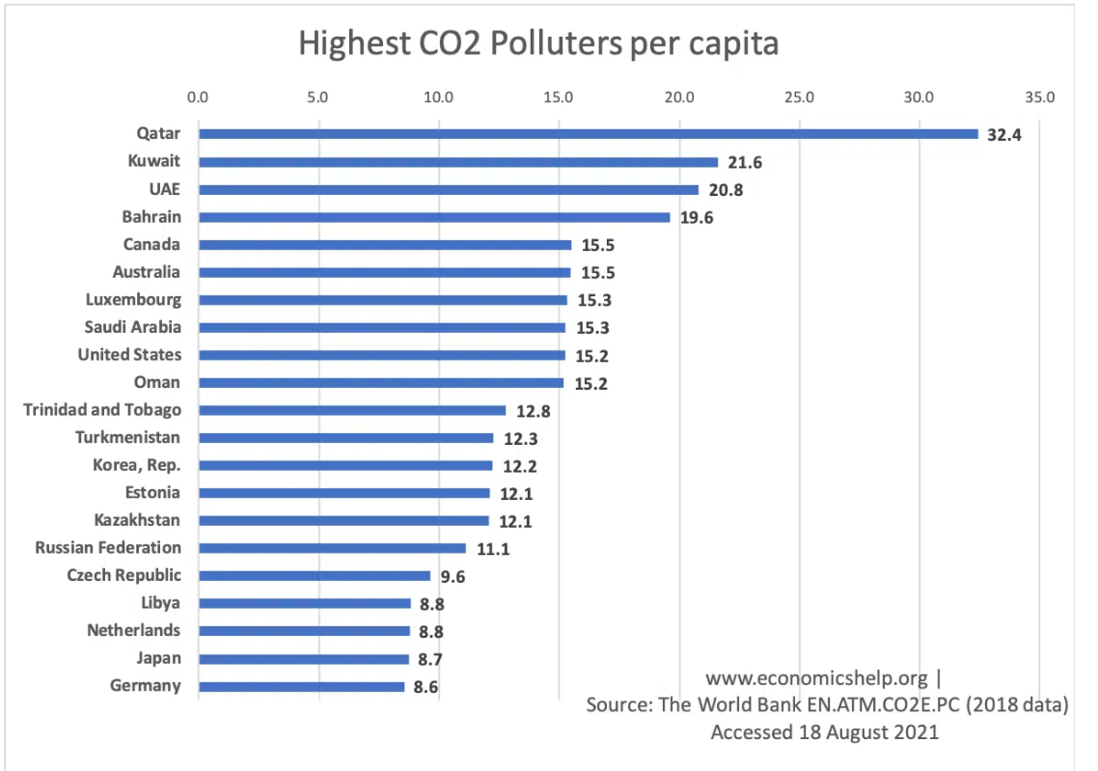

Task 2. Using QR code or links calculate your personal carbon footprint. Compare your result with your classmates.
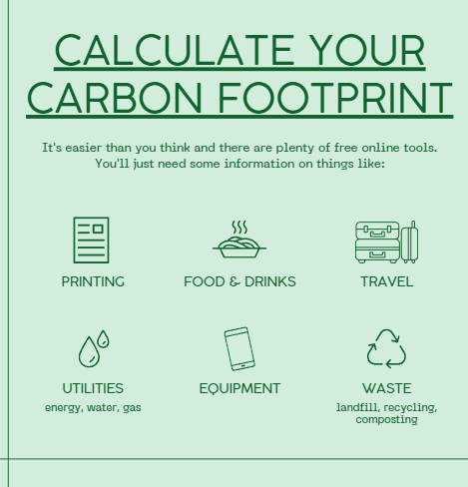 |     https://www.carbonfootprint.com/calculator.aspx  https://www.conservation.org/carbon-footprint-calculator#/individual?zipCodeInfo=usAverage

Unit 5
ENERGY EFFICIENCY

Task 1. Collocate the words electric, improve, energy, reduce with the given groups of words and translate them into your native language:

a) efficiency c) heat pump
___________ costs ________ light bulbs
waste boiler

b) pollution d) efficiency
_________ efficiency _________ insulation
costs environment

WHAT IS ENERGY EFFICIENCY?

Energy efficiency means using less energy to get the same job done – and in the process, cutting energy bills and reducing pollution. Many products, homes, and buildings use more energy than they actually need, through inefficiencies and energy waste. Energy efficiency is one of the easiest ways to eliminate energy waste and lower energy costs. It is also one of the most cost-effective ways to combat climate change, clean the air we breathe, help families meet their budgets, and help businesses improve their bottom lines. Millions of American consumers and businesses choose or invest in energy-efficient products.
Anywhere that energy is used; there is an opportunity to improve efficiency. Some products, like energy-efficient light bulbs, simply use less energy to produce the same amount of light. Other products don’t use energy directly, but they improve the overall efficiency and comfort of a house or a building (such as thermal insulation or windows).
- Light bulbs: An LED light bulb that has earned the ENERGY STAR label uses 70-90% less energy than an incandescent light bulb, while providing the same illumination.
- Windows: Energy-efficient windows are made with materials that reduce heat exchange and air leaks, which means you don’t need as much energy to heat or cool a space.
- Insulation: Adding more insulation to an attic keeps the warm air inside from escaping in the winter. In the summer, it keeps hot air out. With good insulation, you won’t need to use as much energy to keep your house warm in the winter or cool in the summer.
- Smart thermostats: Smart thermostats are Wi-Fi enabled devices that control heating and cooling in your home by learning your temperature preferences and schedule to automatically adjust to energy-saving temperatures when you are asleep or away. They can help you lower your energy bills by not spending money to heat or cool an empty house.
- Computer power management: Computers can be set to automatically enter a low-power “sleep” mode when not in use.
- Homes. The typical household spends nearly $1,900 each year on energy bills and could save 24% or more (about $450) each year by upgrading to efficient ENERGY STAR certified products.

Energy efficiency protects the environment

Most light switches and outlets pull electricity from nearby power plants. These power plants typically burn fossil fuels, such as natural gas and coal. A bi-product of burning fossil fuels is the release of greenhouse gases, such as carbon dioxide, which contribute to climate change.
These power plant emissions also contain other harmful air pollutants, such as nitrogen oxides, sulfur dioxide, and particulate matter that lead to unhealthy air.
Fossil fuels are also often burned directly to heat our buildings, such as in furnaces and boilers, and for water heating and cooking. This can impact indoor air quality in your home, as well as contribute to outdoor air pollution. By using energy more efficiently, we can help reduce emissions of greenhouse gases and other air pollution, fight the threat of climate change, and help to protect our health and the environment.

Energy efficiency saves money

By lowering energy use, energy efficiency reduces monthly energy bills and makes energy more affordable for businesses and families. Some energy-efficient products cost more to buy than other options, but they typically save you money over the long term. For example, an energy-efficient electric heat pump water heater could cost about $700 more than a standard electric water heater, but the energy savings typically add up to $3,500 over the life of the equipment.
Task 2. Make questions to the following sentences and answer them:
1. Energy efficiency means using less energy to do some job and, as a result, to cut energy bills and reduce pollution.
2. Energy efficiency helps eliminate energy waste and lower energy costs.
3. Energy-efficient light bulbs use less energy to produce the same amount of light.
4. Energy-efficient windows are made with materials that reduce heat exchange and air leaks.
5. Good insulation keeps a house warm in the winter or cool in the summer.
6. Power plant emissions contain harmful air pollutants that lead to unhealthy air.
7. Fossil fuels are often burned directly to heat buildings, such as in furnaces and boilers, and for water heating and cooking.
8. By using energy more efficiently, we can help reduce emissions of greenhouse gases and other air pollution, fight the threat of climate change, and help protect our health and the environment.
9. Energy efficiency reduces monthly energy bills and makes energy more affordable for businesses and families.
10. Some energy-efficient products cost more to buy than other options, but they typically save you money over the long term.

Unit 6
ZERO NET HOMES
Over to you:
What is a net zero home, in your opinion? What makes a home so efficient?

Task 1. Make nouns from the words given below:
efficient
generation
consumer
insulation
reduction
distribution
heating
production

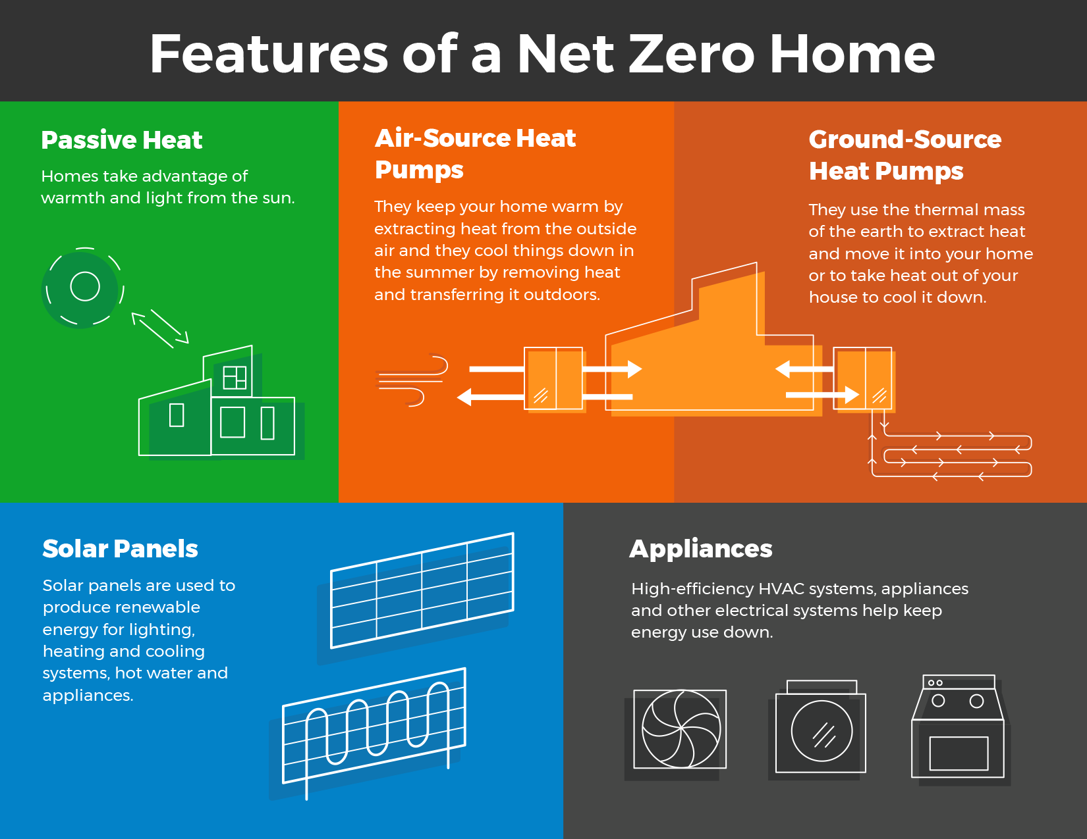
Task 2. A) Read the text and answer the question: What is a net-zero home?
A net-zero home generates as much energy as it uses, so the net amount of energy it purchases from the local hydro company is zero. It's a new idea that's gaining popularity as people become more interested in having a home that is more comfortable and resilient, and also reduces costs to their pocketbooks as homeowners.
B) Read the text and answer the question: What makes a home net zero?
The key to maintaining a net-zero home is to keep energy consumption low so that you can generate enough power to meet your needs. It's challenging, but achievable:
- Net-zero homes are designed to be up to 80 per cent more efficient than conventional homes, so they require less energy to begin with.
- They can be oriented to take advantage of warmth and light from the sun, known as passive heating.
- They are also built to be exceptionally airtight and insulated with additional layers to retain heat in the winter and keep it out in the summer.
- High-efficiency HVAC systems, appliances and other electrical devices help keep energy use down.
- Homeowners also manage their energy use carefully, being mindful of how energy is used around the house.
Net-zero homes also feature on-site energy generation that is capable of producing as much power as the household uses in a year.

C) Read the text and answer the question: How do net-zero homes produce energy?
Not every net-zero home is the same, but they all include their own sources of renewable energy. Many use solar photovoltaic panels that can typically produce energy for lighting, heating and cooling systems, hot water and appliances. Energy from solar panels can be stored in a battery for use later, or sent into the local electricity distribution system and sold to the local hydro company.
Net-zero homes also use highly efficient heating and cooling systems, such as air-source and ground-source heat pumps. Air-source heat pumps draw in outside air and warm it during the winter, and pull warm air outside the house during the summer to keep it cool. Ground-source (also known as geothermal) heat pumps use thermal heat from underground to warm a home during the colder seasons, and pump heat outside during the summer.

D) Read the text and answer the question: Are net-zero homes "off-the-grid"?

A net-zero home can still be connected to the electricity grid, so it can meet changing household energy needs throughout the day and year. For example, being connected to the grid allows homeowners to tap into electricity available from their local hydro company at times when solar production is low, during emergencies, or when maintenance or repair of energy systems are needed.

E) Read the text and answer the question: What is it like living in a net-zero home?
People who own net-zero homes typically find them very comfortable. When a home has highly efficient windows and insulation, it often feels warm without much heating, even on the coldest days. With good insulation, heat is also better distributed around the house. Sometimes the warmth from appliances and home occupants is enough to be comfortable inside. You also won't experience any drafts in a net-zero home. They are tested for air leaks to ensure outside air doesn't affect indoor temperatures. They also use energy recovery ventilators to preheat or cool incoming fresh air.

F) Read the text Read and answer the question: Can an existing home be retrofitted to net zero?

The net-zero concept isn’t limited to new builds. While it takes some planning and changes to conventional renovation approaches, it can be done. Following the same principles for net-zero new homes, renovations include improving existing insulation levels to exceed code standards, orienting windows to work with the sun, redesigning HVAC systems to be as efficient as possible, and installing the energy-generating technology that would work best for the building and its location.

Task 3. Fill in the gaps in the text with appropriate words:

Extract 1

heating distribution sources photovoltaic

Not every net-zero home is the same, but they all include their own _________ of renewable energy. Many use solar _________panels that can typically produce energy for lighting, __________and cooling systems, hot water and appliances. Energy from solar panels can be stored in a battery for use later, or sent into the local electricity ________ system and sold to the local hydro company.

Extract 2

air leaks insulation recovery distributed

People who own net-zero homes typically find them very comfortable. When a home has highly efficient windows and __________, it often feels warm without much heating, even on the coldest days. With good insulation, heat is also better _________ around the house. Sometimes the warmth from appliances and home occupants is enough to be comfortable inside. You also won't experience any drafts in a net-zero home. They are tested for _____ ________ to ensure outside air doesn't affect indoor temperatures. They also use energy ____________ ventilators to preheat or cool incoming fresh air.

SUPPLEMENTARY READING

Unit 7
SUSTAINABILITY AROUND US

TEXT 1

7 Ways To Make Your Coworking Space More Sustainable
The coronavirus pandemic doing the rounds these days has caused a lot of problems for many businesses. Since office attendance was affected due to enforced shutdowns people were forced to work from home or in co-working spaces where it was possible to implement more rigid safety standards than in a crowded office. Let us check out the many ways it is possible to make a coworking space more sustainable:


1. Choose the right co-working space
There are many different types of coworking spaces that are currently available today, and you will have to choose the best one as per your specific energy-saving needs. For example, you can go for a pre-constructed building made of recyclable material or you can install solar-powered panels and hot water geysers to not only heat your water supply but also light up your co-working spaces too. The list of eco-friendly choices is virtually endless and it is up to you to implement as many of them as you want.
2. Encourage people to conserve energy
Encourage the people in the co-working space to put their electronic items in power-saving mode as much as possible, especially when they are not in use. They should also shut them down whenever they leave work. It would be ideal if they unplug them also so that there is no residual current being used.
3. Pick an eco-friendly space beforehand
Before you decide to opt for a green co-working space, you should find such a space in the first place. It would be a good idea to only search for those buildings that are following or have a declared plan to follow green building standards. Many such buildings have been built from eco-friendly construction materials that have been recycled to ensure minimal environmental impact.
4. Power and water efficiency are very important
Energy-efficient products can be more expensive upfront. However, when you compare the costs with their less energy-efficient counterparts, you will see that you easily recover the expense amount in the long run. Apart from that, your whole co-working space will become much more eco-friendly too. From low flush toilets to energy saver bulbs; there are plenty of ways of installing energy-saving products. Best of all, it will decrease your monthly energy bills as well.
5. Say no to extra lighting
Unnecessary lighting is one of the worst ways of using power. Not only does it lead to extra energy bills but it is also a big drain on the local and eventually national grid. Instead of lighting spaces pointlessly when no one is around, it is a much better idea to just simply try to get the job done by using voice activation and motion sensor-equipped lights. This way, you will be able to conserve more energy and make your co-working space more sustainable. You should rely on natural lighting a whole lot more to light up the space. Windows and open doorways will allow both light and fresh air into your co-working space.
6. Promote recycling as much as you can
Recycling makes do with already constructed objects that are repurposed with minimal effort. Such articles require less energy and other resource consumption than freshly constructed stuff. You can install recycling bins near every cubicle where different types of recycling items can be put to good use.
Your co-working spaces can be converted to energy-saving ones provided that you take the right steps. From eliminating paper and single-use crockery to going for solar power, there are plenty of ways of creating the ideal eco-friendly coworking space.

TEXT 2

Recharge Your Batteries: How To Spend Your Free Day In Nature
In this age of gadgets, people are becoming more aware of all the wonderful life benefits that come from spending time outside. Nature is a free source of fresh air and simple pleasure that helps to relax the mind and body, relieve tension, and increase happiness. Despite this recognition of nature’s importance in overall life fulfillment, many people find it difficult to spend time outside because of their extremely hectic schedules.
You might anticipate high-energy, time-consuming hobbies like mountain climbing when you think about attempting to work in more opportunities to appreciate the great outdoors. So, have a look at the top suggestions of how you can spend your free day in-between nature.


1. Start a Garden
You don’t have to be an expert gardener to benefit from digging in the dirt. Begin by planting flowers on either side of your front entrance or herbs in a pot on your porch. Involve your family in the process and come up with new ideas together. You may plant additional flowers in a square of your front lawn or dedicate a tiny portion of your garden to growing your kids’ favorite vegetables. Working outside as a family and getting some exercise while digging or weeding can be a lot of fun.
2. Go for a Bike Ride
You’ll start your day on a bright note if you ride your bike to work. Biking gets your heart pumping and gives you the energy you’ll need for a productive day at work. Fresh air and a clear mind will also help you. Additionally, you won’t have to deal with traffic or find a parking spot. You’ll save money on gas while also lowering your carbon footprint. You can also buy a bicycle motor kit to make the best use of your bike.
3. Have your lunch outside
While eating lunch, find a nearby seat or picnic table and read a book. If you’re lucky enough to live near a park or forests, you may simply sit and enjoy the scenery. Take a walk once you’ve finished eating. You’ll return to work with increased vigor, inventiveness, and focus. Just remember to stay hydrated before and after your walk. Staying hydrated is essential for reaping the benefits of walking.
4. Engage yourself in Nature art
Rock art is one of the simplest nature crafts to showcase both indoors and outdoors. Take your kids on a rock-collecting expedition to collect rocks of all shapes, sizes, and colors. Pull out the paints and paintbrushes when you arrive home and let your kids go to town decorating them. Encourage children to be imaginative by painting them with amusing faces or animals. When they’re dry, put them in a box to keep them secure, set them in the garden for a splash of color, or scatter them throughout a park for other walkers to enjoy.
5. Do exercises among nature
Instead of going to another treadmill session, go for a run at a park near your home or business. Alternatively, you might practice exercises in the fresh air by bringing your yoga mat to your backyard. Exercising outside will arouse all of your senses, and you’ll feel more calm and thrilled than if you worked out in a gym or studio. You might even motivate family members to join you in the gym. Therefore, it is recommended to take out some time to work out in a pen park.
6. Have social gatherings close to the nature
Rather than meeting up with friends at a restaurant or bar, throw a backyard barbeque or picnic in the spring. Your guests may need to layer up a bit more, but they’ll be rewarded with a relaxed atmosphere and plenty of fresh air. Plan a camping trip at a nearby campground or rent kayaks for some water fun if you and your buddies are feeling more daring. These get-togethers will be more memorable than a simple meal or a round of drinks. While some adventurous activities may be fun for some, spending time outside does not require pushing your body to its limits. If you want to spend more time outside, you’ll need to come up with realistic techniques that fit into your hectic schedule. Hopefully, you will try to follow these suggestions and spend your time in nature.

TEXT 3

5 Strategies To Make Your Packaging Sustainable

Do you want to become more sustainable as a brand? Start by upgrading your packaging! Thanks to the high demand for eco-friendly products and the constant efforts of businesses to minimize their negative effects on the environment, sustainable packaging is more popular, accessible, and affordable than ever before. There are many opportunities to embrace sustainability and invest in eco-responsible packaging solutions. If you are ready to start the transformation, keep on reading.


What does “sustainable” really mean?
A sustainable brand is one that highly prioritizes the social and environmental aspects during its full cycle of material sourcing, manufacturing, and transportation. In product packaging, sustainability is choosing eco-friendly packaging that does not contribute to the depletion of natural resources or pollution. Sustainable packaging minimizes carbon footprint emissions, saves water and power, reduces waste generation, and stands firmly behind the idea of a circular economy to ensure the well-being of future generations.
5 strategies for sustainable packaging:
1. Use easily recyclable materials.
If you are new to sustainable practices, investing in packaging made of recyclable materials is a great start. That way, you know that after customers get their products, they could simply recycle or reuse the packaging. Feel free to add instructions for proper recycling to ensure the packaging won’t end up in the landfill. Another perk of easily recyclable materials is the fact that the packaging supplier can recycle and reuse material leftovers, and by doing this, vastly reduce production waste. Some of the most common materials to consider are pulp paperboard, paper, cardboard, and glass
2. Partner with manufacturers with sustainable practices.
Sustainable practices vary from one manufacturer to another. Different factories have adopted different ways of practicing sustainability.
Approaches could be towards minimizing water and power usage, machinery optimization, recycling practices, and so on. It is up to you to decide which local packaging manufacturer shares your vision of being eco-friendly and helping the environment.
3 Opt for smaller packaging
Another viable strategy to make your packaging sustainable is to ship your products in small packages. The fewer packaging materials you use on your product, the lighter and easier for transportation it would be. Reducing the size of your shipments leads to a vast reduction of your company’s carbon footprint due to logistics.
4. Use biodegradable materials
Biodegradable packaging is the embodiment of sustainability. Since it is made from natural sources, it can fully deteriorate upon disposal. Its compostable and dissolvable qualities make this type of packaging extremely eco-friendly. There are not many things that have a more positive effect on the environment than reducing waste in such a smart way. Some of the most interesting biodegradable materials in packaging are plant-based – banana leaves, bamboo, soy, seaweed, etc. Even though it is kind of innovative, unfortunately, plant-based packaging is still very uncommon
5. Try edible packaging
For those culinary and confectionary businesses ready to try unconventional and creative sustainable solutions, the next idea on our list is edible packaging. As you may assume from the name, this type of packaging is absolutely zero waste. It is organic, safe for consumption, and could be composted. Have in mind, though, edible packaging is quite innovative and could come a bit more costly than unconsumable packaging alternatives.
How does sustainable packaging help our Earth?
Sustainability is based on the principle of a circular economy – reduce, reuse, recycle. This principle is all about making the world a better place for future generations. With that in mind, here are some of the environmental benefits of sustainable packaging:
- Uses renewable resources
- Less consumption of raw materials during manufacture
- Saves water and energy during manufacture and storage
- Minimizes waste from product storage
- Reduced transportation costs and safer transport conditions
- Better product conservation and durability
- Safer waste disposal practices
- Biodegradable materials break down fast
- Could be recycled
With sustainable packaging solutions, companies can contribute to improving the environment and reducing their impact on the ecosystem. At the same time, clients can spend their money on socially and ecologically responsible products

REFERENCES

1. Sustainability in Construction. https://www.goconstruct.org/why-choose-construction/whats-happening-in-construction/sustainability-in-construction-1/
2. https://www.investopedia.com/terms/r/renewable_resource.asp
3.Renewable energy. https://www.power-and-beyond.com/what-is-renewable-energy-definition-types-and-challenges
4.Energy-efficiency. https://www.energystar.gov/about/about_energy_efficiency
5. Zero net homes. https://saveonenergy.ca/For-Your-Home/Advice-and-Tips/Net-zero-homes
6. Green Journal https://www.greenjournal.co.uk/
7. WHY THE BUILDING SECTOR? https://architecture2030.org/why-the-building-sector/
8. Cambridge Dictionary https://dictionary.cambridge.org/

